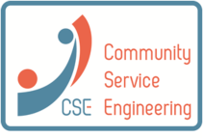
Open Innovation in
Community Service Engineering
Seminar

Thursday May 15th 2014
Haagse Hogeschool, Delft

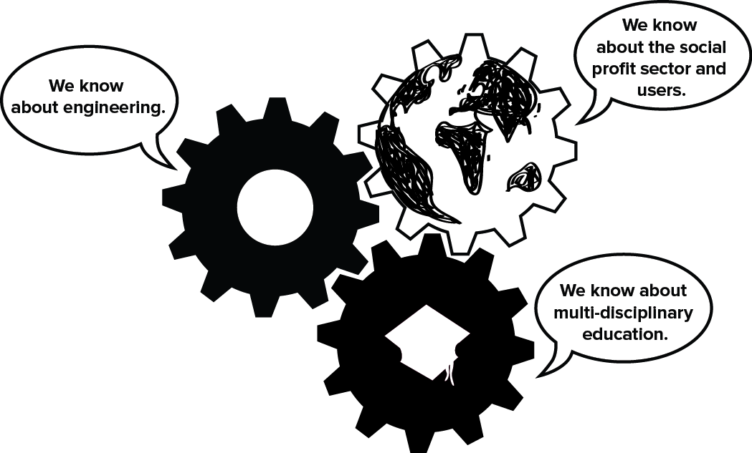

How can we connect the social profit sector, technical industry and (future) engineers to our Higher Educational Institutes (HEI) to achieve open innovation in community service design?

Programme
9:00 Reception & opening
9:30 Key Note speaker Prof. Bert Mulder (ICT&Health)
10:10 Eelco Sengers, Sophia Revalidatie: Parkinson App (how the social profit sector and education can team up for innovation)
10:30 Robert Duiveman, researcher HHS: Laak Vitaal (living lab in neighbourhood setting, continuous educational projects and networking)
10:50 Break
11:10 Kirsten Kasch, Erhvervsakademiet Lillebælt Denmark (welfare technology focused projects in international education setting)
11:30 Martin Seiffers, Accenda BV: Betafactory (how to involve business & HEIs in technological research & development)
11:50 Tour at the Beta Factory & lunch time
13:30 Poster and video presentations of cases, methods and approaches: networking opportunity
15:30 Workshop Design Thinking for Open Innovation via HEI,
moderated by Prof. Rianne Valkenburg (Designerly Innovation)
17:30 Drinks

Free entrance

Location: main hall Haagse Hogeschool, Rotterdamseweg 137, Delft.
Send us an e-mail for registration at s.c.hallenga-brink@hhs.nl
We look forward to welcoming you in Delft and wish you happy networking.

This seminar is a joint effort of the European project Community Service Engineering and the HHS ‘Zwaartepunt Techniek voor Gezondheid’.

